Lower Mokau – Quarterly River Monitoring August
Sample Collection Day: 25th August 2025
Water quality was Fair in the Lower Mokau river (Site 7).
E. coli concentrations were very low (76 cells per 100 mL), meeting both the health guidelines for swimming (540 cells per 100 mL) and guidelines for livestock drinking water (< 100 cells per 100 mL).
Nitrogen: Nitrate was slightly elevated (0.78 mg/L) but fell well below the ecological toxicity levels (2.4 mg/L). Ammonia was low (0.01 mg/L). Dissolved inorganic nitrogen (DIN) was slightly elevated (0.79 mg/L), falling above the ecological impact threshold (0.5 mg/L).
Phosphorus: Dissolved reactive phosphorus (DRP) was very low (0.006 mg/L).
Suspended sediment/Water Clarity: Water clarity was Poor (0.98 m), relative to the national bottom line (1.34 m).
The results in the table below have been graded according to the National Policy Statement for Freshwater Management (NPS-FM, 2020).

Mokau River – Summary of water quality collected from 15 sites across the Mokau River catchment on 25th August 2025

Water quality was Fair across the Mokau River Catchment. While most sites had low to moderate levels of E. coli and phosphorus, 80% of all sites had poor water clarity and exceeded the ecological threshold for dissolved inorganic nitrogen.

E. coli (Microbial Contamination):
- Most sites (73%) had low concentrations (≤ 240 cells per 100 mL), a low risk for swimming.
- Three sites (20%) had very low concentrations (< 100), considered safe for livestock drinking water.
- Four sites (27%) had slightly elevated concentrations (280 - 460 cells per 100 mL).
Nitrogen
Nitrate:
- Three sites (20%) had low concentrations (≤ 0.5 mg/L).
- Twelve sites (80%) exceeded ecological impact thresholds (0.5 mg/L), which can affect stream health.
- All sites fell well below ecological toxicity thresholds (2.4 mg/L) for native fish and invertebrates.
Ammonia:
- Most sites had low concentrations (<0.005 - 0.03 mg/L), of little concern for aquatic life.
- One site (Huioteko stream) had slightly elevated concentrations (0.15 mg/L), which can impact sensitive aquatic species.
Dissolved Inorganic Nitrogen (DIN):
- Three sites (20%) had low concentrations (≤ 0.50 mg/L).
- 10 sites (67%) were slightly elevated (0.51 – 1.0 mg/L), exceeding the ecological impact threshold of (0.5 mg/L).
- Two sites (13%) had concentrations exceeding 1 mg/L, which is of particular concern for aquatic life.
Phosphorus
Dissolved Reactive Phosphorus (DRP):
- Most sites (93%) had low levels (<0.002 - 0.009 mg/L).
- One site (Waitanguru) was slightly elevated (0.012 mg/L), which can contribute to problematic plant and algae growth if levels stay high.
Suspended Sediment / Water Clarity:
- Three sites (20%) had Excellent water clarity (A band).
- One site (Waitanguru stream) had Fair water clarity (C band).
- Nearly three quarters of all sites (73%) had Poor water clarity (D band).
Water clarity bands for each site are based on the National Bottom Line (NBL), which varies depending on local landscape characteristics (e.g. geology, climate, and elevation). For Mokau River sites, the NBL is either 1.34 m or 0.61 m, depending on location.
River Level and Flow Rate – Mokau River, Totoro Road
The below chart presents continuous data collected by the Waikato Regional Council for Mokau River between 1st January and 26th August 2025. River Level and Flow Rate on the day of sampling (25-August) are highlighted.
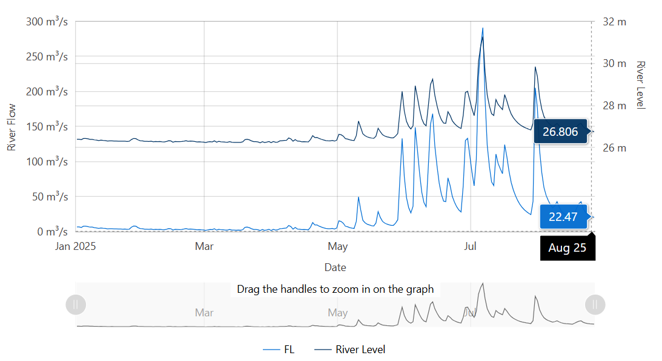
Data source: Waikato Regional Council envirohub website for environmental data.

Drinking water for livestock should contain < 100 cfu/100 mL (median value) of E. coli. Livestock Drinking Water Guidelines (2023), Australian & New Zealand Guidelines for Fresh & Marine Water Quality.

